**LOCATION : NATIONWIDE**

**DATE : 05.01.2018**

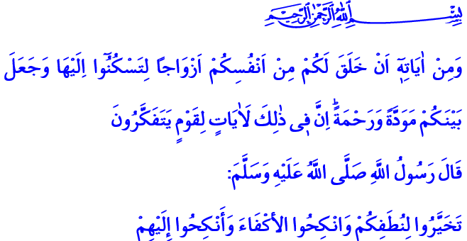

**OUR HEAVEN ON EARTH: THE FAMILY**

**Blessed Friday to You, Honorable Believers!**

A young girl came to our Prophet (pbuh) and said: “O Messenger of Allah! My father wants me to marry his brother's son against my will.” The Messenger of Mercy immediately called the father because he wanted to listen to his side of the story and grant the girl the freedom to choose if he really wanted to marry her without asking her first. The young girl felt safe after this development and said: “O Messenger of Allah! I came to you to find out whether women have a say in marriage.” [1]

**Dear Brothers and Sisters!**

With this behavior, our Prophet (pbuh) suggested that a woman should be consulted and give her consent before marriage, the most important decision of her life. Indeed, he said: **“Do not give your daughters in marriage without their consent.” [2]** And this event was just one of the many examples that shows the place, honor and value of women before our Prophet.

**Honorable Believers!**

Our supreme religion Islam attaches great importance to a healthy marriage and a happy family. Our Prophet (pbuh) gave marriage a deep meaning and a great soul. Because marriage in our religion is a heavy agreement and breaking it is a great sin. Marriage is the oath that the spouses give one another to share a life, holding the name of Allah Almighty as witness. Marriage is a moral and legal responsibility that both women and men assume together with their consent and free will.

In our culture and traditions, marriage is more than bringing two person under a roof. On the contrary, marriage is a solid foundation established for protecting the society and future generations. Being a family is to share a life with love and respect, compassion and mercy, care and sensibility. Being a family is to face all kinds of troubles of the world together. It is to live the joy and sorrow, wealth and poverty together. Being a family is forming a whole through faithfulness and self-sacrifice, through thick and thin.

**Dear Brothers and Sisters!**

We want our families to be our heaven on the earth. We ask our Lord when we start a family: “O Allah! Bless this agreement and make it sacred. Unite this couple with feelings of intimacy, fondness and fidelity. Just like You did with Adam and Hawwa, our Prophet and Khadija, Ali and Fatima.”

We take the steps to the marriage, which gives our lives meaning and makes it bountiful, in the presence of our parents, relatives and neighbors, brothers and sisters, and our loved ones. We also make people witnesses to our marriage that we started with the name of our Lord, with the intention to make it last a lifetime.

And we ground the foundations of our warm homes on the capacity, mutual consent, love and fidelity of the couples to be married. Because marriage is not a relationship of one-sided interest. On the contrary, marriage is about a couple deciding their future together. No one has the authority and right to capture another person’s will, to claim ownership over her or him, and to determine her or his future. Allah is the sole owner of souls. And in the words of our Prophet, the husband and wife are entrusted to one another.

**Honorable Believers!**

Despite all this, occasionally people could give children in marriage who do not have the ability to distinguish between right and wrong, good and evil. Moreover, some groups try to ground these false perceptions and practices arising from ignorance and irresponsibility to the religion.

It is a fact that in Islam, marriage is a serious step that is closed to arbitrary and random practices. Marriage requires consciousness and responsibility. In our religion, freedom of will is required for responsibility, punishment and reward. It is absolutely impermissible in our religion to take away the right of a person to live his or her life with dignity, and in particular to expose children to various kinds of abuse. There is no religious and scientific legitimacy, no foundation for a child who is not yet aware of her responsibility for her Lord and her environment to be forced into marriage. It is unacceptable to try to marry a girl who has not reached the age of understanding how to build a home, be a wife and a mother. The rights of both sides in marriage must be observed in order to ensure the permanence of peace and happiness in the family, in the direction of our religion’s principles and our Prophet’s (pbuh) sunnah.

**Brothers and Sisters!**

I want to conclude this khutba with a verse and a hadith:

Our Lord Almighty enjoins in the Quran: **“And among His Signs is this, that He created for you wives from among yourselves, that you may find repose in them, and He has put between you affection and mercy. Verily, in that are indeed signs for a people who reflect.” [3]**

Our Prophet (pbuh) says: “**Select (fit) women (in respect of character) for your seed, and marry (your) equals and give (your daughters) in marriage to them.” [4]**

1. An-Nasai, The Book of Marriage, 36; Ibn Ḥanbal, VI, 135.
2. Al-Bukhari, Book of Wedlock, Marriage (Nikaah), 42.
3. Rum, 30/21.
4. Ibn Majah, The Chapters on Marriage, 46.

   ***Written by: General Directorate of Religious Services***